[How to Use a Bread Maker](https://www.wikihow.com/Use-a-Bread-Maker)

Bread makers have simplified the process of making bread at home, because they take over the kneading and baking for you. In fact, all you need to do to have fresh bread every day is pour in the ingredients and press a few buttons! Bread machines are generally quite easy to use once you understand what all the functions are, but if you’re using a new machine and don’t know what all the buttons do, it can be quite intimidating. If you are using a new machine for the first time, read over the manual first, and go through it to figure out what all the buttons and functions are for, in what order to add ingredients, and in what order you should program the different functions. You may even find that your bread machine can make more than bread.

**1.Learning the Basic Functions**

Put the bread pan and paddles into the machine. These are the components that will be responsible for mixing, kneading, and baking your bread. Open the lid on the top of the machine. You’ll see a heat element in the bottom and a place where the bread pan sits inside the machine.

Insert the pan into place, and then place the paddles (sometimes called the blades) on top of the peg inside the pan.

To remove the pan from the machine again, use the handle and give it a gentle pull.

The paddle will knead the bread, and the metal pan is what the bread will bake in.

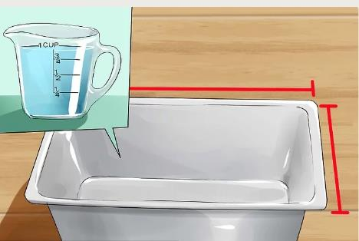

**2.Determine the size of your bread maker.**

Bread machines have different capacities, and some can make small, medium, or large loaves of bread. It’s important to determine the capacity of yours, because you can’t overfill your bread maker.

Add one cup of water at a time to the bread pan, keeping track of how many cups you added. Add water until the pan is full.

For a machine that holds fewer than 10 cups, you can make one-pound loaves. For a machine that holds 10 cups, you can make 1.5-pound loaves. For 12 cups, your bread can be two pounds. More than 12 cups indicates a 2.5-pound loaf.

A small to medium loaf of bread (one to 1.5 pounds) will have around two cups of flour, while a medium to large loaf (two to 2.5 pounds) will be around three cups.

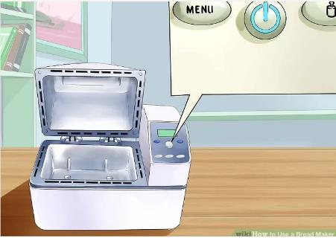

**3.Find the power button if there is one.**

Dump or reuse the water from the bread pan. Replace the pan and paddles inside the bread machine. Close the lid, and plug in the machine. Most machines will come on automatically, but there may be an on/off switch.

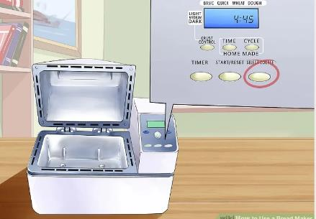

**4.Find the Select button.**

The Select button allows you to begin programing your bread maker according to your ingredients and preferences. The different settings you’ll be able to choose include:

Loaf size

Crust darkness

Flour type

Rapid cycle

Dough-only

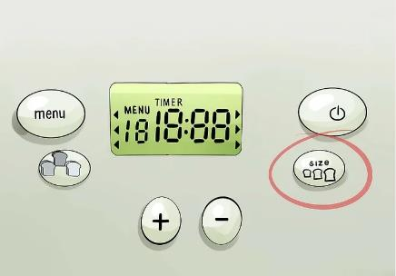

**5.Learn how to select loaf size.**

Some larger bread machines have a button that allows you to select the size of the loaf you’re making, and this will adjust the baking time of the machine accordingly.

Most bread machines will have a single Loaf button, and you can push this multiple times to change the setting.

As you change the setting, pay attention to how it alters the time on the display. [[3]](https://www.wikihow.com/Use-a-Bread-Maker#_note-3)

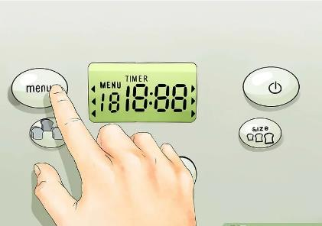

**6.Understand the different flour settings**.

Bread machines have different settings for different flours, and this is because your loaf will take a longer or shorter time to bake depending on the type of flour, such as white versus whole wheat.

Some flours have a longer kneading and rising time, while others can be put on a rapid cycle.

There are some bread maker models that don’t have flour types written right on the machine. Instead, you may have to select a menu number that corresponds with different flour types.

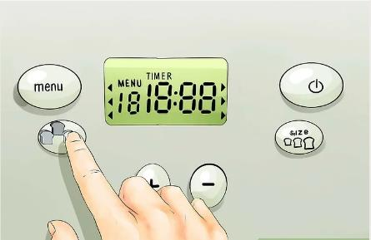

**7.Find the crust control.**

Many bread makers allow you to control the crustiness or darkness of your crust, because it will add a longer or shorter baking time to your setting.

Like the Loaf control, your machine will likely have a single Crust button that you can push multiple times to change the setting.

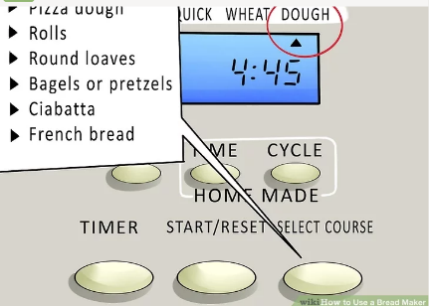

**8.Try the dough-only setting.**

This setting is for when you just want the bread machine for mixing, kneading, and rising, but not baking. This comes in handy when you’re making non-loaf breads, such as:

Pizza dough

Rolls

Round loaves

Bagels or pretzels

Ciabatta

French bread

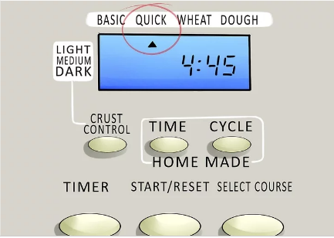

**9.Find the rapid cycle.**

The rapid cycle is a quicker version of the bread machine process for when you’re in a hurry, but keep in mind that even this will usually take at least one hour. You also likely won’t be able to choose custom settings like crust darkness when you select this option.

When you have the time, it’s recommended that you allow your machine to go through the full cycle, because this gives the yeast and ingredients the proper time to activate.

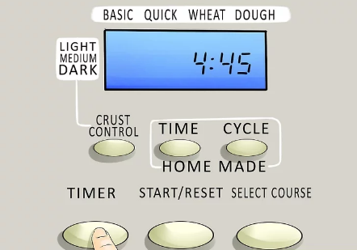

**10.Master the time delay.**

The time or delay setting allows you to program your machine to start its cycle at a later time. For instance, you can put all your ingredients into the machine in the morning, set the delay for five hours, and then your bread will be ready when you get home after work.

To use the time delay, use the up and down arrows to add or subtract time from your programmed setting.

Once you select your flour type, bread size, and crust setting, your bread machine will give you a cycle time, such as three hours, for example. You can add five hours (so the time display will read eight hours), which means your bread maker won’t start the process until five hours have elapsed.

Never use the delay cycle for recipes that contain dairy or other ingredients that should always be refrigerated.

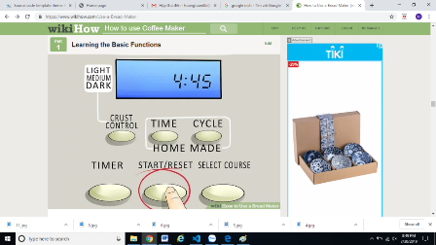

**11.Locate the start button.**

You can play with the settings on your machine all you want, and the machine won’t start mixing, kneading, or baking until you actually hit Start. When you do hit Start, the machine will begin its cycle, or will begin counting down through the time delay.

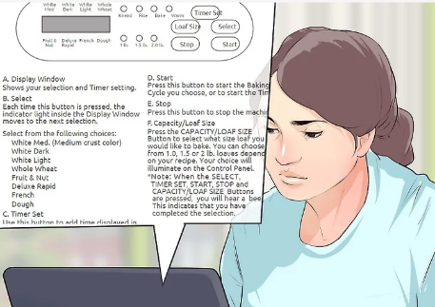

**12.Troubleshoot problems.**

The bread machine manual should have all the information you need regarding the functions, how to solve different problems, and possibly even some tasty recipes. But if you have lost your manual, take a look online to see if you can find a digital version.

.